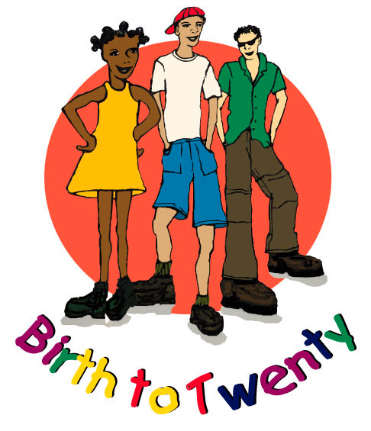

University of the Witwatersrand

Department of Paediatrics and Child Health

BIRTH TO TWENTY MEDICAL SCHOOL SITE: 16TH YEAR
ADOLESCENT FRACTURE QUESTIONNAIRE

DATE : Day Month Year

BTT ID NUMBER :

BONE STUDY ID NUMBER :

FRACTURES

1. Have you broken or fractured a bone in the past year?

YES NO

If YES, please tell me about the different times this occurred

Incident number | Which bone did you break or fracture? | When did this happen? (Date) | How did this happen?
1

2

3

4

5

Interviewer

